Alex McLaurian
1-28-14
CS560
Lab 1 Report

- I created both an ER diagram and a UML diagram, as shown below.
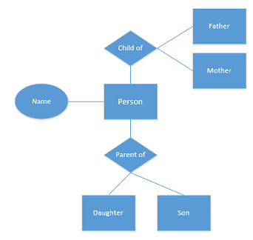
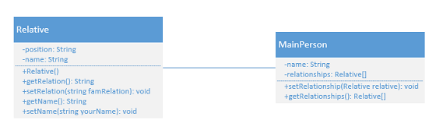
The UML diagram is relatively simple, as I took the approach that the diagram would be looking at one person's connection to all of their relatives, who can share the same basic attributes. There is room to increase attributes which might call for the Relative class to be virtual, with Parent/Wife/Child/etc. classes inheriting properties from it.

- I will be using my github account created from last semester as I am continuing to develop last semester's project.

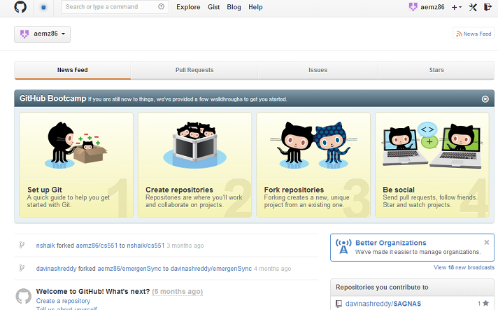
- I will also be using my already created scrumdo account to be able to analyze previously created user stories.

